






















Special Education Advisory Council
ANNUAL REPORT

Relating to SEAC Activities July 1, 2016 to June 30, 2017


Message from
the
Chair

So much has happened this year. We utilized the Leading by Convening process for a full year. It was well received and proved helpful in focusing SEAC on areas of concern. Our four main areas this year were on recruitment and retention of special education personnel, inclusion, professional development and student assessment. The most difficult task was seeking to balance these areas with emergent issues. The format also gave the Department of Education a better way to partner with us on information sharing and reviewing policy.
We accomplished much this year, the most exciting
of which is sharing our opinion with the Department and the Board of Education on the Strategic Plan for 2017-20 and the draft ESSA State Plan. We also met with legislators and shared with them our concerns regarding budget and educational issues.
We are pleased that we were able to ensure special education had a voice in the process of developing the Board of Education’s Strategic Plan, the Governor’s Blueprint for Education and the Every Student Succeeds Act state plan. While not all of our suggestions were incorporated, some of them were, and we are hopeful all this work will lead toward better educational equity for all students with disabilities.
SEAC bids a fond farewell to Superintendent Kathryn Matayoshi. We appreciate her leadership and accomplishments. SEAC also welcomes the incoming Superintendent, Dr. Christina Kishimoto and looks forward to working with her on improving special education. We also welcome the new Director of the Monitoring and Compliance Office, Christina Tydeman with whom we have already started partnering and expect to continue a positive and fruitful relationship.
My thanks to former Deputy Superintendent Stephen Schatz and Assistant Superintendent Suzanne Mulcahy for the time they spent with SEAC and sharing their expertise with us.
My thanks to all the members of the Special Education Advisory Council for their hard work, and I look forward to another year as chair.
We hope that special education stakeholders find the information in this report of interest and value. SEAC always welcomes your feedback.

Martha M. Guinan









Contact
Information
for
SEAC
Special Education Advisory Council (SEAC) 1010 Richards Street, Room 118
Honolulu, HI 96813
(808) 586-8126 / Voice(808) 586-8162 / TTY
(808) 586-8129 / Fax
Email: seac.hawaii@gmail.com or spin@doh.hawaii.gov Website: http://www.seac-hawaii.org

1

Contents

Purpose, Vision & Mission1
Functions of the Council2
SEAC Membership.2
Student Population Data3-6
Major Areas of Focus SY 16-177-9

Leading by Convening • SEAC Vision of Inclusion
Annual Performance Report/State Systemic Improvement Plan • Strategic Plan Input • Every Student Succeeds Act (ESSA) • Board of Education Interface • Due Process Review • Legislative Action • Public Outreach
Future Direction for SY 17-189
Recommendations to the Superintendent. 10-13 Member Roster14

Purpose

SEAC shall provide policy guidance with respect to special education and related services for children with disabilities in the State. (IDEA, CFR 300.167)
Vision
SEAC believes in optimizing the educational achievement of every child through a strong public education system that is proactive and supportive of students, families and educators. To that end SEAC will use its strength as a broad based constituency group to play an active and influential role in decisions affecting policies, programs and services.
Mission
The mission of SEAC is to guide and assist the Hawaii Department of Education in fulfilling its responsibility to meet the individual needs of children with disabilities.
2


Functions
of
SEAC

- Advise the Department of Education of unmet needs within the State in the education of children with disabilities. CFR 300.169(a)

- Comment publicly on any rules or regulations proposed by the State regarding the education of children with disabilities. CFR 300.169(b)

- Advise the Department of Education in developing evaluations and reporting on data to the Secretary of Education, U.S. Department of Education, under Section 618 of the Individuals with Disabilities Education Act. CFR 300.169(c)

- Advise the Department of Education in developing corrective action plans to address findings identified in federal monitoring reports. CFR 300.169(d)

- Advise the Department of Education in developing and implementing policies relating to the coordination of services for children with disabilities. CFR 300.169(e)

- Monitor the implementation of activities and timetable pursuant to consent decrees or court orders regarding the education of children with disabilities. (IDEA 90 regulation maintained by SEAC because of the Felix Consent Decree).

- Advise on the education of eligible students with disabilities who have been convicted as adults and incarcerated in adult prisons. (IDEA 97 regulation maintained by SEAC with representation by the Department of Public Safety).

- Review Hawaii special education due process hearing decisions and findings. (CFR 300.513).

- Review and comment with regards to the Department’s federal and state budgets for special education.
SEAC
Membership

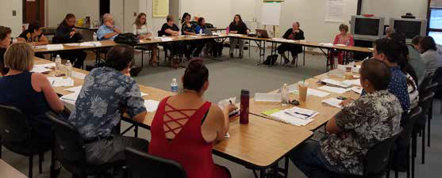
SEAC is made up of a diverse group of individuals with expertise in a variety of aspects affecting special education and related issues. Persons with disabilities and parents of children with disabilities comprise a majority of the membership. Members are appointed by the Superintendent and serve without compensation for three-year terms. A roster of SEAC members for School Year 16-17 can be found on page 14.
3


The
Students
that
SEAC
Represents

Distribution of Students by Eligibility Category
Hawaii’s special education students are deemed eligible for services through at least one of the 13 disability categories of the Individuals with Disabilities Education Act (IDEA), or an optional category of developmental delay. This latter category applies to children aged 3-9 who have
a developmental delay in one or more of the following areas: physical development, cognitive development, communication, social or emotional development or adaptive development.
Ages 3 through 5

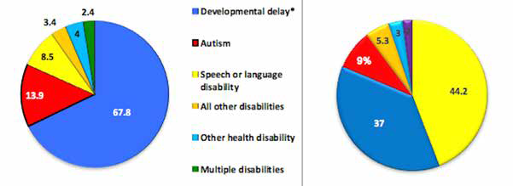
Hawaii Students Ages 3 thru 5 (%) Nat’l Average of Ages 3 thru 5 (%)
Almost 68% of Hawaii’s 2,491 preschoolers and Kindergartners in SY 16-17 were deemed eligible through the category of developmental delay, allowing services to be provided without assigning one of the 13 disability categories. This is done in part because it is sometimes difficult to assess the true nature of a child’s disability at such a young age. Hawaii serves more young students with autism (14%) than the national average (9%), but fewer students under the category of speech/language disabilities (8.5% compared to 44%).
Ages 6 through 21

Hawaii Students Ages 6 thru 21 (%) Nat’l Average of Ages 6 thru 21 (%)
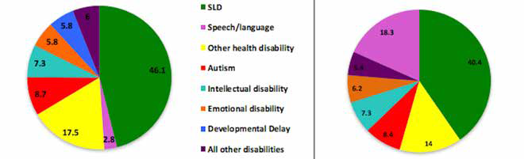

The data above displays the distribution of students 6 through 21 years of age by eligibility category in Hawaii as compared to the national average. The total number of Hawaii’s school- age students with disabilities counted this school year is 16,884. Almost half (46.1%) of these students were found eligible under the category of specific learning disabilities. For students aged 19 to 22, most were found eligible through the categories of Intellectual Disability, Multiple Disabilities or Autism..
Source: OSEP Part B Data Display: Hawaii, 2015
4


The
Students
that
SEAC
Represents
(cont.)

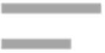
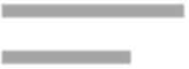
Numbers of Students Served Hawaii serves a smaller percentage of students with disabilities than the national average, leading some to question whether Hawaii is under- identifying students with special needs. In SY 16-17, the 18,969 students with Individualized Education Programs (IEPs) represented 10.6% of Hawaii’s public school students. This contrasts with the most recently published national average of 13.0% in 2015.
Comparison of SWD Served Hawaii vs. Nation
6 thru 21
8.9
6.3
3 thru 5
6.3
4.4
Na;on
Hawaii
0
2
4
6
8
10
Percentage of the Total School Popula;on
The U.S Department of Education requires states to report child count data
(the number of special education students served each year) in two broad age categories--3 through 5 years and 6 through 21 years of age. The table at the right shows that Hawaii served a smaller percentage of students with disabilities than the national average in both age groups.
Source: OSEP Part B Data Displays, Hawaii & U.S.

Student Achievement
For measuring the academic achievement of students with disabilities in Hawaii, two assessments are highlighted:

 The Smarter Balanced Assessment (SBA) is Hawaii’s primary statewide assessment tool implemented in SY 14-15. It is aligned with the Common Core State Standards and given to all students in grades 3-8 and grade 11 in the spring. Hawaii is one of about 18 states using the SBA for accountability purposes. The charts below show the percentage of students in three main categories (SPED, not high need, and high need) who achieved proficiency in English Language Arts (ELA) and Math over the last four years, including two years of data from the Hawaii State (HSA) Assessment which was used previously.
The first bar or category in red represents students with disabilities who take the same statewide assessment as their non-disabled peers. The green bar shows achievement results for a combined category of “high needs” students which includes students with disabilities, students eligible for free or reduced lunch and students who are English Learners. The blue bar represents students without high needs. Students with disabilities have been consistently falling 50 percentage points behind these non-high needs peers
in both Math and ELA. They also tend to be performing well below the combined group of high needs students.
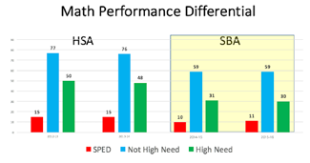
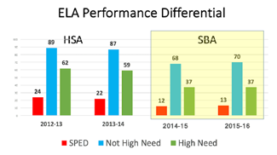
Source: SBA & HSA Reporting for SY 12-13 to SY 15-16.

The
Students
that
SEAC
Represents
(cont.)

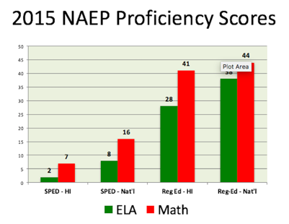
 The National Assessment of Educational Progress (NAEP) is referred to as “the nation’s report card” because it is administered to groups of students in the fourth and eighth grades in every state since the 1990s and allows for performance comparisons between states. Although
Hawaii’s regular education 4th and 8th graders have been making gains on the NAEP
in past years, the special education 4th and 8th grade scores are among the lowest in the nation, alongside special
education students in New Mexico, Mississippi, and Alabama.
Source: National Center for Educational Statistics, 2015 Reading & Math Assessment Report Cards

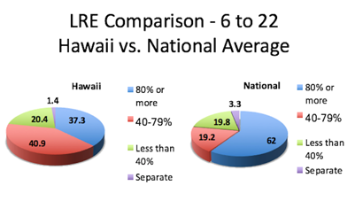
Least Restrictive Environment IDEA requires IEP teams to consider placing students with their non-disabled peers to the maximum extent appropriate. Hawaii special education students spend less time in the general education classroom than students in any other state or territory. In SY 2016-17, only 37.3% of our students with IEPs spent 80% or more of their day in the general education classroom. This is in stark contrast to the national
average of 62%. Source: DOE SY 16-17 LRE Data compared to SY 15-16 OSEP Data

Chronic Absenteeism
5
One of the student success indicators utilized in Hawaii’s accountability system is a school’s chronic absenteeism rate. In SY 2015-16, the chronic absenteeism rate for non-special education students was 13.7%. By contrast students with disabilities had nearly double the rate --24.2%. Missing a
lot of instructional time is likely to negatively affect a student’s overall performance and likely a contributing factor to the wide achievement gap between special education students and students and their non-disabled peers.


Chronic absenteeism is defined as 15 or more days absent
in a school year.

6

The
Students
that
SEAC
Represents
(cont.)

Suspensions
In 2015 the Office of Civil Rights published national discipline data showing students with disabilities are more than twice as likely to receive an out-of-school suspension (13%) than students without disabilities (6%). In Hawaii, that trend bears out In SY 2015-16 , 3.9% of all public school students were suspended, but 9.2% of school-aged special education students were suspended (2.4 times more).

Students with Disabilities Suspended in SY 2015-16

Out-of-School 10 Days or Less | Out-of-School More than 10 Days | In-School  10 Days or Less | In-School More than 10 Days
1356 | 195 | 444 | 14
Source: IDEA Part B Data Tables, Table 5, School Year 2015-16

Graduation Rates

In SY 14-15 (the latest year for which data is available) the special education graduation rate was 60.4%. It is calculated as the group of students who begin as first-time 9th graders in a particular school year and who graduate with a regular high school diploma in four years or less. By comparison, the overall graduation rate is twenty percentage points higher at 82.0%.

Due Process Safeguards
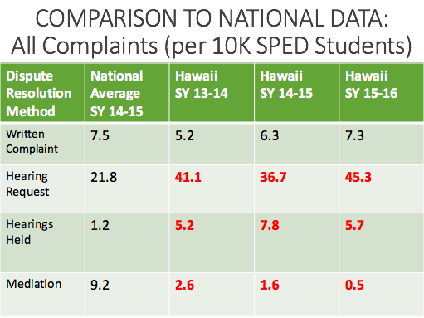
When parents of students with disabilities disagree with their child’s identification, evaluation, program, placement, or discipline they have to right to due process safeguards--mediation, written complaints and due process hearings--to try to resolve the conflict. Despite a significant reduction in due process hearing requests over the last five years, Hawaii still out paces the national average in the number of hearing requests filed, and the number of those requests that result in a due process hearing decision. By contrast, Hawaii parents use mediation--a less adversarial process--much less than most Mainland parents.

NOTE
The rates in the table to the left are calculated on a per capita basis in order to compare small states to larger states. The rates represent the number of
uses of a dispute resolution method per 10,000 special education students.

Source: DOE 618 Due Process Data for SY 13-14 to SY 15-16 and CADRE
National Data for SY 14-15.
7


Major Areas
of
Focus
for
School
Year
16-17

Leading by Convening
At the beginning of the school year, the leadership of the Department of Education agreed to partner with SEAC in using the Leading by Convening (LBC) process to help solve complex issues related to special education. Developed by the IDEA Partnership LBC helped SEAC in:
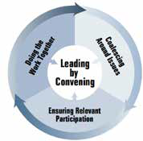
√ coming together around shared concerns or problems of practice that need fixing;
√ working to get the right mix of stakeholders to commit to preparing to move forward; and
√ practicing shared leadership and modeling respect for one another’s experience and expertise.
To allow time for deep discussions, members and the Department selected four main issues to highlight over the course of meetings: recruitment and retention of special education personnel, inclusive education, professional development and student assessment.
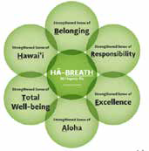
(For more information about LBC, go to: http://seac-hawaii.org/leading-by-convening/).

SEAC Vision of
Inclusion
One solution offered by SEAC to enhance quality inclusive placements for students with disabilities was the development of a comprehensive vision of inclusion to give schools an awareness of the elements needed for success. SEAC’s vision of inclusive
education for ALL students, including those with disabilities, is built upon the Nā Hopena Aʻo framework. This framework of values and beliefs based on Hawaiian culture is incorporated into the Hawaiʻi Department of Educationʻs Strategic Plan, as well as the Blueprint for Public Education.
(For a copy of SEAC’s Vision of Inclusion go to: http://seac-hawaii.org/share-your-ideas/.

Annual Performance Report/State Systemic
Improvement Plan
(APR/SSIP)
The Annual Performance Plan (APR), with its targeted state plan for systemic improvements (the SSIP), is the U.S. Department of Education’s main monitoring tool for ensuring that states are both 1) complying with the provisions of IDEA, and 2) providing appropriate supports to special education students to result in their positive academic and functional performance. In August, SEAC reviewed the Office of Special Education Programs’ determination that for the third year in a row Hawaii “needs

assistance” in implementing the requirements of the Individuals with Disabilities Education Act. The latest finding was based in large part on Hawaii’s APR of SY 2015-16 reporting low student proficiency on the Smarter Balance Assessment and the National Assessment of Educational Progress (NAEP). SEAC previewed the data on Indicators 1-16 of the APR for SY 15-16 that was submitted in February 2017 and helped set targets for drop-out rates (Indicator 2) and
pre-school outcomes (Indicator 7). Members also offered input on the final draft of the State Systemic Improvement Plan submitted two months later in April.
(The APR and SSIP can be found at: http://www.hawaiipublicschools.org/TeachingAndLearning/ SpecializedPrograms/SpecialEducation/Pages/home.aspx)
8


Major Areas
of
Focus
for
School
Year
16-17
(cont.)



Strategic Plan Input
The Strategic Plan outlines the Department’s expectations for the achievement of specific goals that improve public education. In revising and extending its Plan to SY 2017-2020, a large emphasis was placed on closing the achievement gap and providing both equity and excellence to all of Hawaii’s public school students. SEAC worked through the Deputy Superintendent and the Board to advocate for specific equity targets for special education, the adoption of a smaller group size for accountability purposes and the inclusion of teacher retention as an indicator of student success.
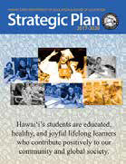
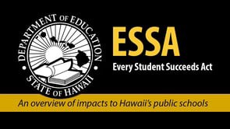
(For more information on the Strategic Plan, go to: http://www.hawaiipublicschools.org/ VisionForSuccess/AdvancingEducation/StrategicPlan/Pages/home.aspx).

Every Student Succeeds Act (ESSA)
The ESSA State Plan is Hawaii’s accountability plan under the federal law that protects the rights of educationally disadvantaged students, including students with disabilities. SEAC provided input on initial and final drafts of Hawaii’s Plan to be submitted early next school year, and participated in the Governor’s Partners in Education workgroup to refine
the Blueprint for Public Education. In addition, SEAC’s Chair attended ESSA Boot Camp: Advocating for Equity and Achievement in ESSA Implementation conducted by The Education Trust organization. The boot camp brought together advocates from the business, civil rights, disability, social justice, and education reform communities to discuss both the
opportunities and risks for advancing equity and improving achievement under the Every Student Succeeds Act (ESSA). The Hawaii team has continued to meet and advocate for educational equity through ESSA and all other opportunities.
(For a copy of SEAC’s testimony on the ESSA Plan go to: http://seac-hawaii.org/board-of- education-testimony/).
Board of Education
Interface
SEAC’s partnership with the Board of Education has been  strengthened by the input of Vice Chair Brian De Lima at

monthly SEAC meetings and his championing of special education issues on the Board’s agendas. In addition to testifying numerous times on the Strategic Plan and the ESSA State Plan, SEAC offered input on the following topics: DOE’s biennium budget, the recruitment and retention of teachers, an audit of student assessments, and special education inclusion. We were also privileged to have representation on the Advisory Committee assisting the Board’s search for a new Superintendent.

Due Process Review
For the past thirteen years SEAC has conducted an annual review of due process activity--mediation, written complaints and due process hearing requests and decisions--to determine how well Hawaii schools are resolving conflicts between special education parents and school personnel and to look for opportunities to promote early dispute resolution. This year’s review examined activity for SY 14-15 and SY 15-16. Findings included a higher (cont.)
9


Major Areas
of
Focus
for
School
Year
16-17
(cont.)


Due Process Review (cont.)
percentage of due process hearing requests and hearing decisions per capita than the national average and a much lower percentage of mediations. Hawaii has continued to improve on resolving hearing requests through resolution sessions or other means, prior to going to due process hearing.
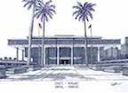
(For a copy of SEAC’s 2017 Due Process Review, go to: http://seac-hawaii.org/reports/).

Legislative Action
SEAC’s Legislative Committee met regularly with the Coalition for Children with Special Needs both prior to and during the legislative session to ensure broad-based support for bills affecting students with disabilities. SEAC also met with key legislators to educate them on current priorities of the special education community. Testimonies supported the Department’s Biennium Budget, Affordable Care Act health coverage, an
early intervention data system, expanding educational funding by applying a surtax on rental properties, sexual abuse education, the Hawaii Keiki: Healthy & Ready to Learn program, and expansion of the Early Learning Program, including additional Pre-Kindergarten Preschool teachers for new classrooms.
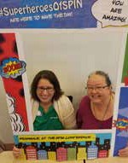
(For copies of SEAC’s testimonies, go to http://seac-hawaii.org/testimony/).

Public Outreach
SEAC reaches out to the public and interested applicants by 1) hosting an informational booth at the annual SPIN Conference to provide information about SEAC to the more than 450 parents and helping professionals who attend each year, 2) widely disseminating SEAC rack cards and brochures widely throughout the year, 3) inviting public participation at monthly meetings where at least fifteen minutes are set aside in each meeting agenda to allow for public input, 4) and soliciting input through a “Share Your Ideas” page on the SEAC website. In
SY 16-17 SEAC also connected with the Hawaii State Teachers Association, Teach for America and the Governor’s ESSA Team.



Future
Directions
for SY
17-18
Department of Education leadership and SEAC members are committed to working together during the coming year using the Leading by Convening process to address shared priorities that will positively impact students with disabilities. In addition to following up on the four priority areas selected for problem-solving this school year, SEAC plans to:
- Meet with Superintendent Christina Kishimoto and her leadership team to identify mutual priorities and opportunities for partnership;
- Participate with the Hawaii State Teachers Association in soliciting input from special education teachers during their annual “Road Show” of focus groups around special education teaching and learning conditions; and
- Work with the Department and the Board to implement SEAC’s Vision of Inclusion.


Recommendations
to
the
Superintendent

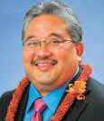
One of SEAC’s most important responsibilities is to advise the Department of Education of the unmet needs of students with disabilities and formulate recommendations to address these needs. Our six priority recommendations are highlighted in yellow.

Keith Hayashi
Interim Superintendent
Christina Kishimoto
Superintendent (as of 8/17)

10
SPECIAL EDUCATION STAFFING SHORTAGES

Issue #1: The current proportional staffing methodology to distribute special education teaching positions from the State to the Complex Area to individual schools is not based on the needs of individual students, resulting in many schools reporting critical staff shortages that negatively impact instructional support.

Priority Recommendation:
Consider incorporating SEAC’s two proposed changes to the method of assigning teachers
and educational assistants: 1) create four staffing support categories—intensive, sustained, targeted and intermittent—with specific weights based on the amount of instructional minutes in the IEP, and distribute personnel by calculating the collective weights of students per individual school; and 2) incentivize inclusive practices by setting a lower staffing ratio for students served in the general education classroom for 80% or more of the school day.
Issue #2: Hawaii’s chronic shortage of certified special education teachers is exacerbated by poor retention. Research has shown that high quality induction and mentoring programs are effective retention strategies. However, teachers have told SEAC and the Board of Education that there are not always special education certified mentors to support new teachers of dis- abled students.

Recommendation:
Provide dedicated special education teachers to provide quality mentoring and induction to spe- cial education teachers who are new to the field and/or encountering instructional challenges in the classroom.
PROFESSIONAL DEVELOPMENT / TEACHER PREPARATION

Issue #1: Hawaii must set teacher qualifications for all teachers, including special education teachers, under the Every Student Succeeds Plan. The final ESSA draft plan failed to distin- guish a different set of criteria for special education teachers. It is not practical to require these teachers to demonstrate subject matter competence in all areas they are assigned to teach (by passing PRAXIS in each subject). However, in order to meet the diverse needs of students with disabilities, some minimum training or coursework must be required to ensure effective instruction.

Recommendation:
Require special education teachers to complete (to be determined) minimum requirements/ coursework and demonstrate knowledge prior in order to meet ESSA teacher qualification standards.
Issue #2: A growing number of emergency hired teachers are assigned to special education classrooms. In order to receive a special education certification, they must complete a State Approved Teacher Education Program (SATEP). Post Baccalaureate students at the University of Hawaii currently have been reported to be less prepared and less likely to remain in the field than students who complete Dual Preparation degrees.

11


Recommendations
to
the
Superintendent
(cont.)
PROFESSIONAL DEVELOPMENT / TEACHER PREPARATION
(CONT.)

Recommendation:
Work with the University of Hawaii and other State Approved Teacher Education Programs to incentivize recruiting more Dual Preparation degree candidates.
Issue #3: Very few training opportunities offered by the Department of Education are open to parents, other family members and contracted providers who are serving students with disabilities, despite ample research to show the benefits of inclusive training on student outcomes and family-school partnerships. Utilizing key parents as co-trainers would model partnership to training audiences.

Priority Recommendation:
Open professional development activities to family members and contracted providers to
ensure coordinated support of student needs, and include knowledgeable parents as members of training teams to model family-school partnerships and family expertise.
Issue #4: A number of recent HSTA surveys and focus groups have highlighted limited access to educator training around the effective inclusion of students in the general education class- room, including strategies for successful co-teaching partnerships.

Priority Recommendation:
Provide more targeted training for special education and general education teachers, especially
in the area of co-teaching and inclusion.
INCLUSION /
INCLUSIVE EDUCATION

Issue #1: Roughly 2/3 of Hawaii’s students with disabilities spend the majority of their day outside of the general education classroom, while national averages show the reverse. IDEA’s strong preference is for students to receive their educational program in the general education classroom to the maximum extent possible. SEAC’s Vision of Inclusion was developed using the tenets of Nā Hopena A‘o to assist schools in making appropriate inclusive placements for students with disabilities.

Priority Recommendation:
Work with SEAC to implement our Vision of Inclusion in Hawaii’s public schools.
Issue #2: Twenty-one public preschool classrooms and a number of charter school preschool classrooms have been recently funded to serve children who have limited access to quality preschool due to income or geographic location. Although SEAC received assurances that a natural proportion of students with disabilities would be included within these classrooms, to date we have not seen these programs following through on their commitment.

Recommendation:
Ensure that public preschool classrooms serving students without disabilities also accommodate students with disabilities in natural proportions to provide greater opportunities for early childhood inclusion.
Issue #3: Placing students with disabilities in a general education classroom in unnatural proportions and with inadequate services and supplementary supports have resulted in poor outcomes for students with and without disabilities and a mistaken belief by some schools that “we tried inclusion and it doesn’t work.”

Recommendation:
Adopt clear definitions for commonly used terms, such as inclusion, and provide training and materials to demonstrate what inclusion looks like.
12


Recommendations
to
the
Superintendent
(cont.)
INCLUSION /
INCLUSIVE EDUCATION
(CONT.)
Issue #4: A number of studies have noted that forced pairings of teachers and inadequate planning time to deliver instruction to students with and without disabilities in a general education classroom can inhibit trust building, parity and effective teaching.

Recommendation:
Encourage voluntary pairings and flexibility for co-teaching teams.

STUDENT ASSESSMENT
Issue #1: There is broad acknowledgment amongst teachers and disability groups that authentic assessments provide more meaningful feedback for teaching and a truer reflection of student understanding and skills than statewide assessments. There is also a recognition that statewide testing can contribute to student anxiety and lost instructional time.

Recommendation:
Apply for a State Waiver for Innovative Assessments under the Every Student Succeeds Act State Plan.
Issue #2: A recent Internal Audit of the Student Assessment Administration revealed that testing accommodations and designated supports are not consistently administered to students with disabilities who have documented needs for these supports.

Recommendation:
Require mandatory training of testing coordinators and special education teachers to ensure that appropriate designated supports and accommodations related to the Smarter Balance Assessment and other statewide assessments are included in the student’s IEP and tracked for implementation.
STRATEGIC PLAN / ACCOUNTABILITY FOR SUBGROUP PERFORMANCE

Issue #1: In December 2016, the Department and the Board of Education approved a Strategic Plan for 2017-2020. The plan contains fourteen student success indicators and set a baseline performance and target for each based on ‘all student’ totals. While the plan addresses the issue of equity, it does not set baselines and target goals for individual subgroups, including students with disabilities.

Recommendation:
Set distinct targets (equity metrics) related to special education students and other ESSA identified subgroups for each applicable student success indicator.
Issue #2: The draft ESSA currently utilizes an “n” size of 20 students for accountability purposes, thereby excluding 15% of special education students. An “n” size of 10 excludes only 5% of special education students from accountability reporting. In addition, the U.S. DOE uses 10 as the minimum number for reporting data related to special education and student discipline.

Priority Recommendation:
Reduce the “n” size for reporting special education student performance, as well as other sub-
group performance, from the “n” size of 20 to an “n” size of 10 in order to ensure that schools are held accountable for the academic improvement of high needs subgroups.
Issue: A proposed Strive HI 3.0 on-line school report card shows overall performance scores but requires the user to access a link to another page to find scores for special education and other high needs students.
13

Recommendations
to
the
Superintendent
(cont.)
STRATEGIC PLAN / ACCOUNTABILITY FOR SUBGROUP PERFORMANCE (CONT.)

Recommendation:
Revise the proposed school report card to show academic performance scores for special education students alongside the overall performance results, in order to raise awareness and present a clear picture of school performance.
SECLUSION AND RESTRAINTS

Issue: The Department contracted with Quality Behavioral Solutions to certify trainers as part of the response to the mandatory training required by the passage of the Restraints and Seclusion legislation in 2014, and these trainers are responsible for training school teams on
the appropriate application of behavioral interventions. Parents of students at risk of restraints and long term substitutes serving these students are excluded from training opportunities.

Priority Recommendation:
Include interested parents and substitute teachers in training around preventive and early
intervening behavioral strategies and techniques.
LEADING BY CONVENING

Issue: SEAC has successfully utilized the process of Leading by Convening (LBC) to address with DOE leadership persistent problems adversely affecting students with disabilities. More data and technical assistance are required to enhance decision-making.

Recommendation:
Continue LBC’s shared problem solving between SEAC, Department leadership and the special education community, and expand the circle of informers to include the technical assistance experts offered by the Office of Special Education Programs through the Annual Performance Report development and implementation.
ANNUAL PERFORMANCE REPORT / STATE SYSTEMIC
IMPROVEMENT PLAN

Issue #1: The current English Language Arts growth and proficiency targets for third and fourth graders with IEPs under the eligibility categories of Specific Learning Disabilities, Other Health Disabilities and Speech/Language Disabilities are set too low for students to close the achievement gap with their non-disabled peers.

Recommendation:
Further revise the State-identified Measurable Result (SiMR) to reflect an accelerated trajectory of growth in reading achievement (greater than that for general education students) as well as higher proficiency targets in order to benefit more students and reduce the huge achievement gap between students with IEPs and non-high needs students.

Issue #2: As SEAC members and their partners coalesce around issues and seek solutions for longstanding and complex issues, they need support to expand their ability to analyze data and become more knowledgeable about intervention tools and strategies.

Recommendation:
“Grow” the expertise of key stakeholder groups involved in annual performance report planning by offering ongoing training and information on data analysis, evidence-based interventions and strategic planning methodologies.


1144




Member Roster SY 16-17
SEAC
Ms. Martha M. Guinan, Chair Individual with a Disability Ms. Dale Matsuura, Vice Chair (Staff Success) Student Services Coordinator, Honolulu District Dr. Patricia Sheehey, Vice Chair (Student Success) Parent/Univ. of Hawaii/Charter School Ms. Ivalee Sinclair, Vice Chair (Legislation) Individual with a Disability

Ms. Brendelyn Ancheta Parent - Kauai District
Ms. Deborah Cheeseman Special Education Teacher - Honolulu District Ms. Annette Cooper Parent - Central District
Ms. Gabriele Finn District Educational Specialist - Windward District Mr. Sage Goto Developmental Disabilities Division, DOH
Ms. Valerie Johnson Division of Vocational Rehabilitation, DHS Ms. Cathy Kahoohanohano Representative of Students Who Are Homeless, DOE Ms. Bernadette Lane Child Welfare Branch, DHS Mr. Thomas Moon Youth Corrections/Vice Principal- Olomana School
Ms. Kaili Murbach Parent - Maui District
Ms. Stacey Oshio Youth Corrections/Principal - Olomana School
Ms. Kau’i Rezentes Parent - Leeward District
Ms. Charlene Robles Early Intervention Section, DOH Ms. Rosie Rowe Parent Training and Information Center
Mr. James Street Representative of Private Schools Dr. Todd Takahashi Adult Corrections/Department of Public Safety Dr. Dan Ulrich Parent/Child & Adolescent Mental Health Division, DOH Mr. Steven Vannatta Community Representative
Dr. Amy Wiech Parent - Central District
Mr. Gavin Villar Parent/Autism Consultant Teacher Ms. Jasmine Williams Parent - Honolulu District
Ms. Susan Wood Parent - Hawaii District

Dr. Christina Tydeman Liaison to the Superintendent
Dr. Robert Campbell Liaison to the Military

Ms. Amanda Kaahanui Staff
Ms. Susan Rocco Staff

