Attachment A - SEAC Meeting, August 12, 2022
Q&As
2022 OSEP Determination by Brikena White and the Monitoring & Compliance Branch Team

Q/Comment: While OSEP allows our hearing officers to allow extensions to the 75 day timeline set in IDEA for the delivery of a due process hearing decision, I suspect Hawaii has longer legal delays than other states.

A/Comment: The Department is in the process of analyzing the data for SY 21-22.

Q/Comment: Covid may have impacted secondary transition but it is not the primary reason. Even with the 2020 HIDOE postsecondary transition guideline, schools do not demonstrate working knowledge to apply information in the guideline. Many schools are not aware of the guidelines.

A/Comment: While COVID-19 impacted postsecondary transition, our data indicates that we need to improve the development of transition plans not only to meet Indicator 13 compliance, but also prepare our students for post-school activities. The Monitoring and Compliance Branch, the Exceptional Support Branch, and District Educational Specialists have been training staff at the high schools statewide on Indicator 13 requirements.

Q/Comment: What assessments are available to the high school care coordinators?

A/Comment: There are a variety of assessments (formal or informal) that high schools use to determine a student’s preferences, interests, needs, and strengths (PINS) when developing a student’s postsecondary transition plan. Assessments can include but are not limited to: student interview, family interview, aptitude tests, interest inventories, observation, job shadow, employer/work study evaluation, etc…

Q/Comment: Which high school have you all done the transition training with? My son just transitioned into high school and administration did not have it together. Until I helped them get it together. Will the training be offered every year due to staff turnover?

A/Comment: The Department has trained staff in nearly all of the high schools on the requirements of Indicator 13 and continues to offer the trainings to ensure new staff are trained.

Q/Comment: Will there be training for parents on post-secondary transition?

A/Comment: The Department is developing training on postsecondary transition for our parent community. Stay tuned, more information to follow.

Q/Comment: My understanding is that the transition plan starts at 14 and is required to be completed by age 16. How is Hawaii doing statewide with entry at 14 and completing by 16 years of age?

A/Comment: In the state of Hawaii, the transition service needs focusing on the student’s courses of study must be addressed starting at age 14, or earlier if the IEP team deems appropriate. By age 16 (or younger if the IEP team deems appropriate), Indicator 13 secondary transition requirements must be met. For federal reporting purposes, the data reviewed and analyzed for Indicator 13 only applies to the students with IEPs ages 16 and above.

Q/Comment: What efforts have been made to incorporate Perkins V funded opportunities for high school students?

A/Comment: Perkins V funds are allocated by the University of Hawaii (UH) State Career & Technical Education (CTE) Office to the Hawaii State Department of Education’s Office of Curriculum and Instructional Design's Curriculum Innovation Branch, Career Readiness Section. Perkins funds are provided to schools for resources and services to identified schools and complex areas that are developing and implementing improvements and expansions for CTE programs. To be able to spend Perkins funds, schools and districts create CTE one-year plans that are approved by the Principal and CAS. Each school and district may have various focus areas for CTE and will differ based upon their one-year plan.

The state is in the process of rolling out 13 new career pathways that align with local economic, employment, and postsecondary need areas. The 13 pathways will create opportunities for students to enter high skill, high wage, and high demand career fields. In addition, the new pathway structure gives students opportunities for work-based learning experiences, industry recognized credential attainment, postsecondary credit attainment, employability, and technical skills training. For more information, please visit the Department’s CTE public facing website at: https://www.hawaiipublicschools.org/TeachingAndLearning/StudentLearning/CTE/Pages/default.aspx

Q/Comment: Do you know how many states received needs assistance determination and how the statistics changed overall from previous years? (It would be helpful to see where Hawaii has slid on the scale on a national level and over time-also can see how states have stepped up or down under these unusual circumstances). This may be also helpful to see states in their best practices.

A/Comment: Please see below for the states that were determined as Needs Assistance for the last two years (2021 and 2022 Determinations).
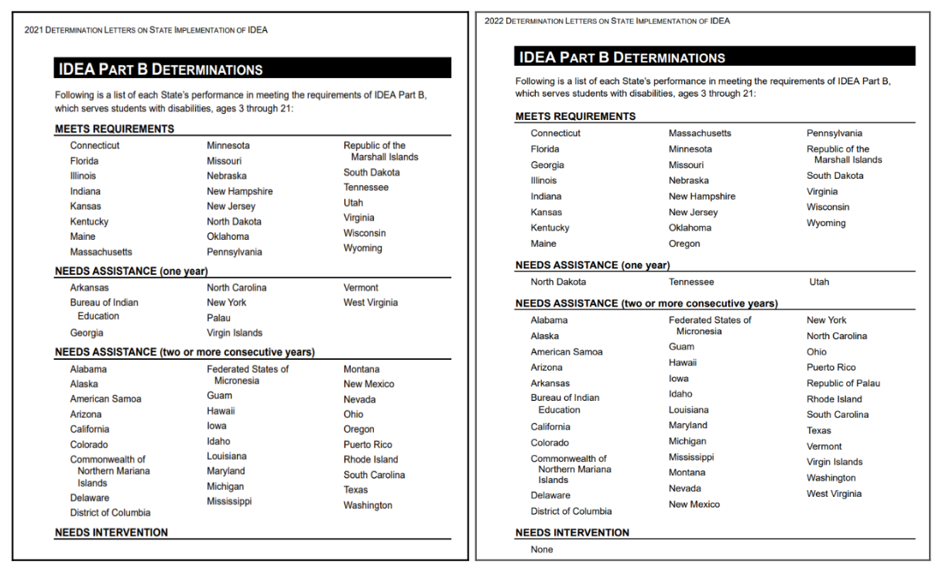

Q/Comment: My understanding is that native Hawaiians are our highest risk populations. Is there a national/state outreach organization to improve our cultural competency?

A/Comment: The National Center for Systemic Improvement (NCSI) is funded by the U.S. Department of Education’s Office of Special Education Programs. NSCI has been providing technical assistance and webinars on equity, culture, and disability. Additionally, the National Center on Educational Outcomes (NCEO) focuses on the inclusion of students with disabilities, English learners, and English learners with disabilities in instruction and assessments.

Q/Comment: Indicator 7 - HIDOE needs to have a continuum of LRE for our preschoolers within the neighborhood the child lives in. To only have sped classes in the child's neighborhood is unacceptable. To place preschoolers on the bus transportation for an hour or more to get to an inclusion or general ed setting is unacceptable.

A/Comment: The Department continues to work with other public agency programs, such as HeadStart and the Executive Office on Early Learning (EOEL) Public Pre-Kindergarten program, and utilizes Kindergarten settings to support opportunities for preschool children with disabilities to be in classes alongside their typically developing peers.

Q/Comment: Why is reading focusing on 3rd and 4th grade and not 1st and 2nd grade? Seems we should start younger to make sure kids are reading earlier and not farther behind?
A/Comment: State priority areas include Indicator 7: Preschool Outcomes and Indicator 17: State Systemic Improvement Plan (SSIP) which focus on improving early language and literacy. The measurement for Indicator 17: SSIP for English Language Arts for 3rd and 4th grade students eligible under OHD, SoL, and SLD was determined by the Hawaii State Department of Education staff, students, parents, community members, partners in other state agencies, and providers. The stakeholders analyzed the state’s data and infrastructure, and provided recommendations on the selected improvement strategies, chosen measurable result, and theory of action. For more information, please visit the Department's website at: https://www.hawaiipublicschools.org/VisionForSuccess/SchoolDataAndReports/StateReports/Pages/Special-Education-Performance-Report.aspx

